1. Implement below Program using Java Apache POI Concept. Read data from MS-Excel Sheet and Print it in IDE Console
Prepare an Excel Sheet with below columns and insert multiple rows of the data.
EMP No
EMP Name
EMP Designation
EMP Salary
EMP Department
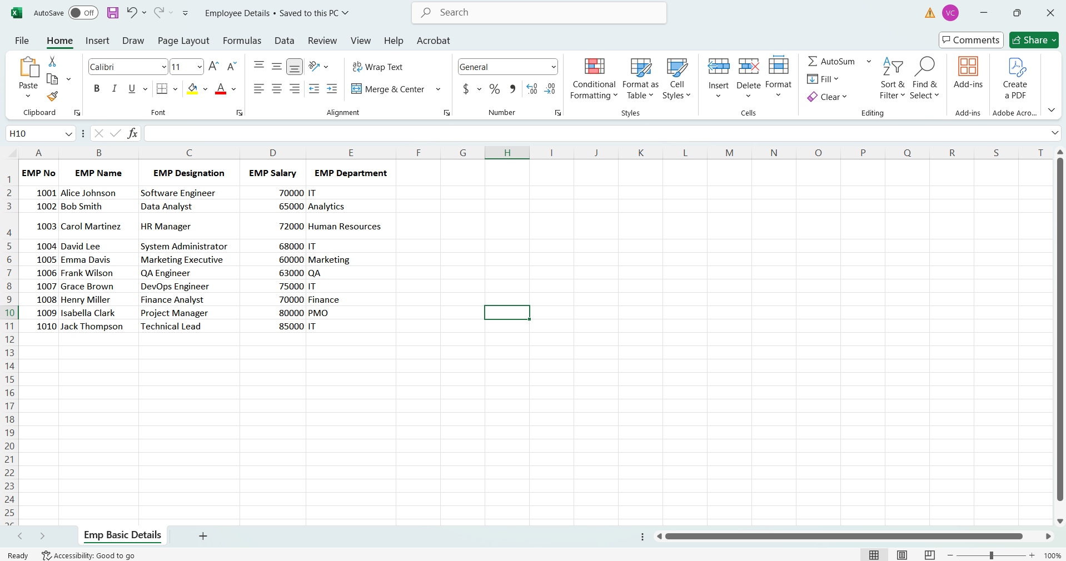

Eclipse

Maven pom.xml file:
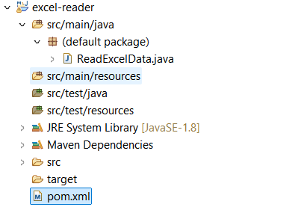
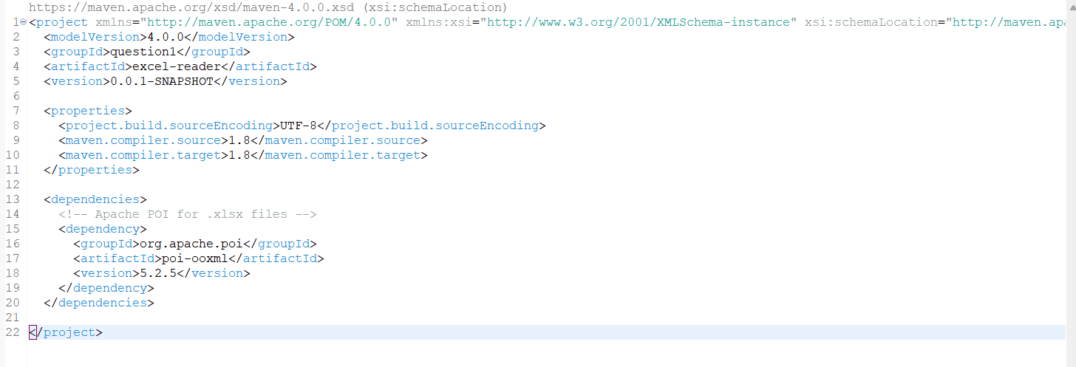
<project xmlns="http://maven.apache.org/POM/4.0.0" xmlns:xsi="http://www.w3.org/2001/XMLSchema-instance" xsi:schemaLocation="http://maven.apache.org/POM/4.0.0 https://maven.apache.org/xsd/maven-4.0.0.xsd">
<modelVersion>4.0.0</modelVersion>
<groupId>question1</groupId>
<artifactId>excel-reader</artifactId>
<version>0.0.1-SNAPSHOT</version>

<properties>
<project.build.sourceEncoding>UTF-8</project.build.sourceEncoding>
<maven.compiler.source>1.8</maven.compiler.source>
<maven.compiler.target>1.8</maven.compiler.target>
</properties>

<dependencies>
<!-- Apache POI for .xlsx files -->
<dependency>
<groupId>org.apache.poi</groupId>
<artifactId>poi-ooxml</artifactId>
<version>5.2.5</version>
</dependency>
</dependencies>

</project>

Java Code:
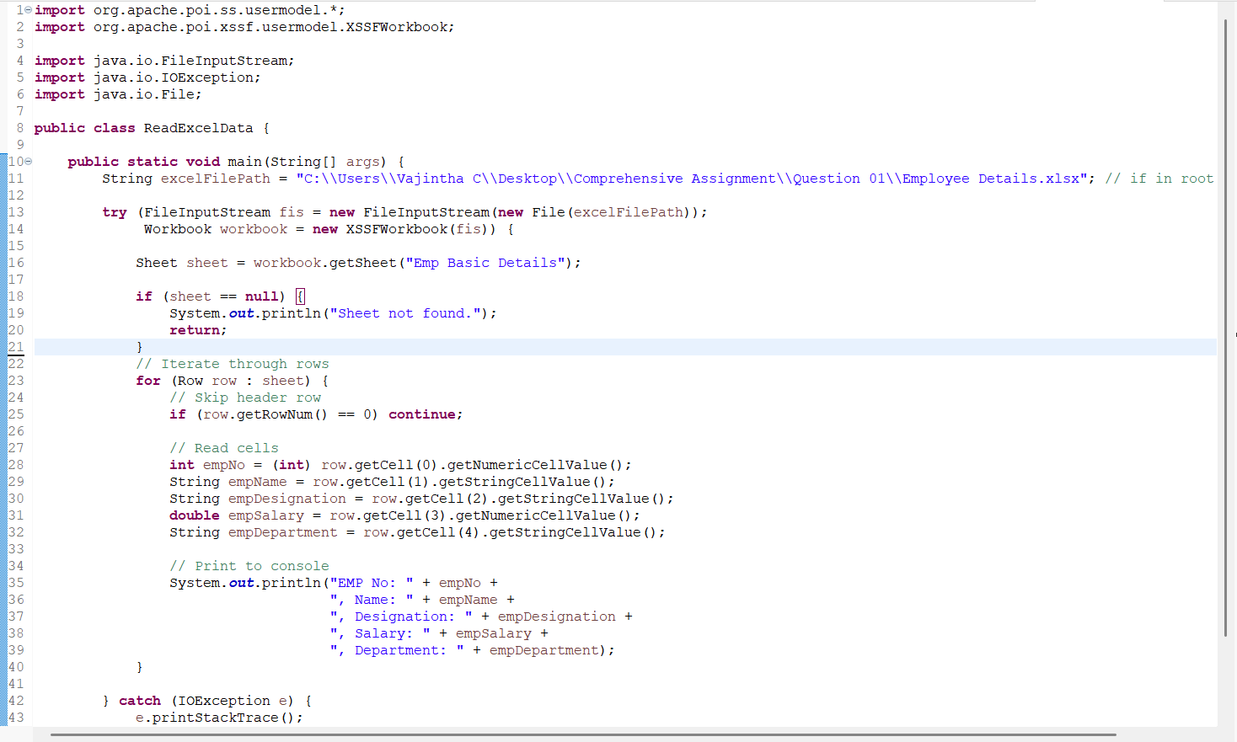
import org.apache.poi.ss.usermodel.*;
import org.apache.poi.xssf.usermodel.XSSFWorkbook;
import java.io.FileInputStream;
import java.io.IOException;
import java.io.File;

public class ReadExcelData {

public static void main(String[] args) {
String excelFilePath = "C:\\Users\\Vajintha C\\Desktop\\Comprehensive Assignment\\Question 01\\Employee Details.xlsx"; // if in root of project

try (FileInputStream fis = new FileInputStream(new File(excelFilePath));
Workbook workbook = new XSSFWorkbook(fis)) {

Sheet sheet = workbook.getSheet("Emp Basic Details");

if (sheet == null) {
System.out.println("Sheet not found.");
return;
}
// Iterate through rows
for (Row row : sheet) {
// Skip header row
if (row.getRowNum() == 0) continue;

// Read cells
int empNo = (int) row.getCell(0).getNumericCellValue();
String empName = row.getCell(1).getStringCellValue();
String empDesignation = row.getCell(2).getStringCellValue();
double empSalary = row.getCell(3).getNumericCellValue();
String empDepartment = row.getCell(4).getStringCellValue();

// Print to console
System.out.println("EMP No: " + empNo +
", Name: " + empName +
", Designation: " + empDesignation +
", Salary: " + empSalary +
", Department: " + empDepartment);
}

} catch (IOException e) {
e.printStackTrace();
}
}
}

Output:
